Introduction
This test program intends to demonstrate the seal performance under site conditions after several reports of failure and inconsistency of leakage.
The subject of this testing is mechanical seal order 950969 modified. This version of mechanical seal was designed based on new seal faces geometry to include lasered wavy face technology.

Test N°1 – (Aug 23 – Aug 29, 2023)
First test intends to confirm calculation results based on same operating conditions on site. Although, barrier fluid has been changed to Mono-Ethylene Glycol + water mixture, this test will be conducted with water, change in barrier fluid will be introduced in next test run.

Seal Configuration
Seal faces
 | Part Drawing | Material | Face condition
Sleeve (1) | C0619166NL | Alloy C-276 | New
Inner Seal Stator (14) | C0618722SL | Silicon Carbide (SL) | New
Inner Seal Rotor (15) | C0619339SL | Silicon Carbide (SL) | New
Outer Seal Stator (14.1) | C0618722SL | Silicon Carbide (SL) | New
Outer Seal Rotor (15.1) | C0618723SL | Silicon Carbide (SL) | New

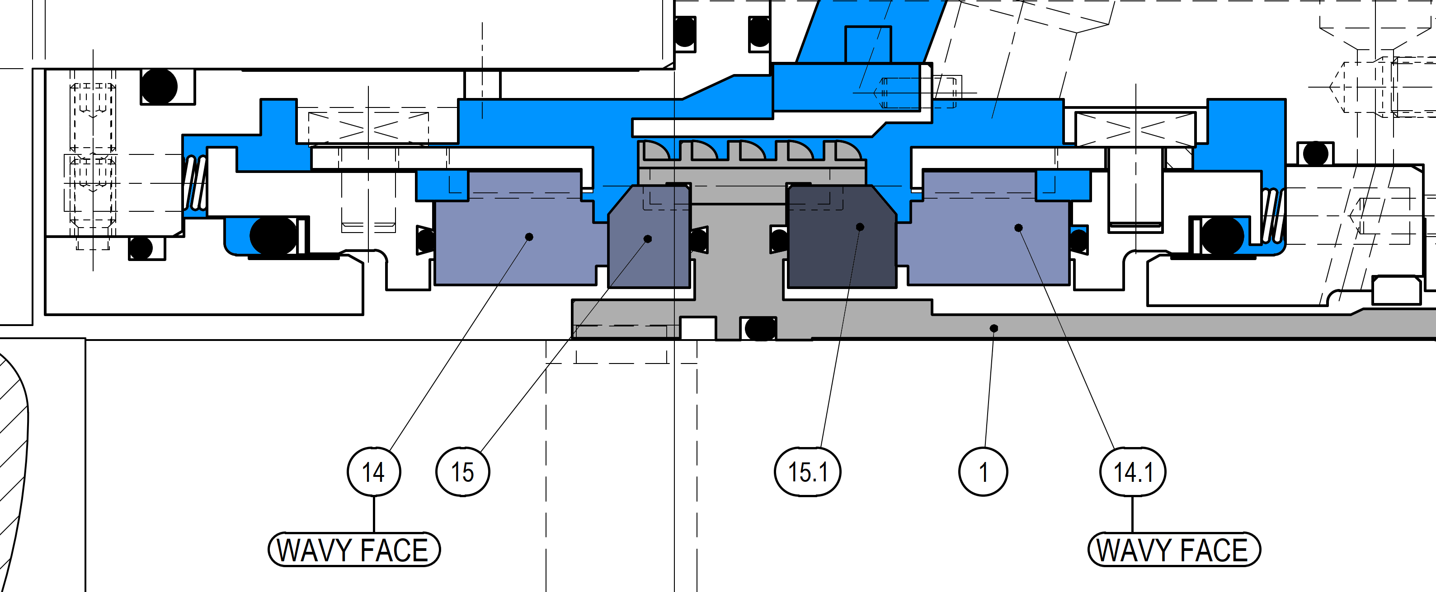
Cross Section of The New Parts

Test Conditions & Results
 | Job seal barrier
Duration | Minimum 72h
Speed | 2950 rpm
Fluid | Water
Pressure | 70 barg
Inlet temp. | 40 °C
Outlet temp. | 43 °C
Inner Seal Leakage | Avg. 16.1 ml/h
Outer Seal Leakage | Avg. 14.4 ml/h
Flow | 13.2-12.2 l/min

Tester Drawing D0571813
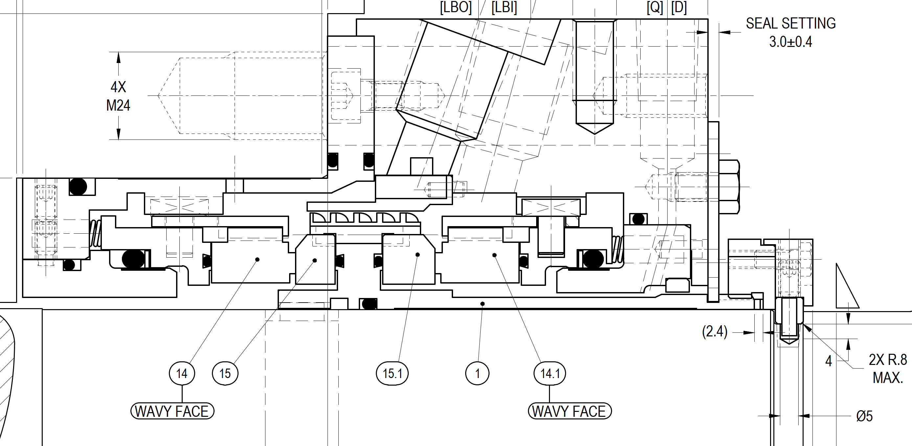

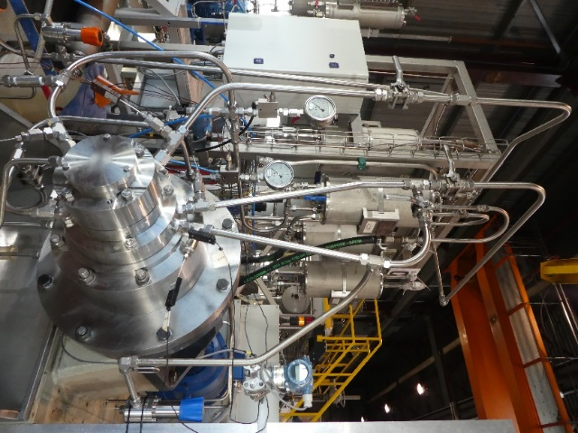
Tester unit B
Logged Data
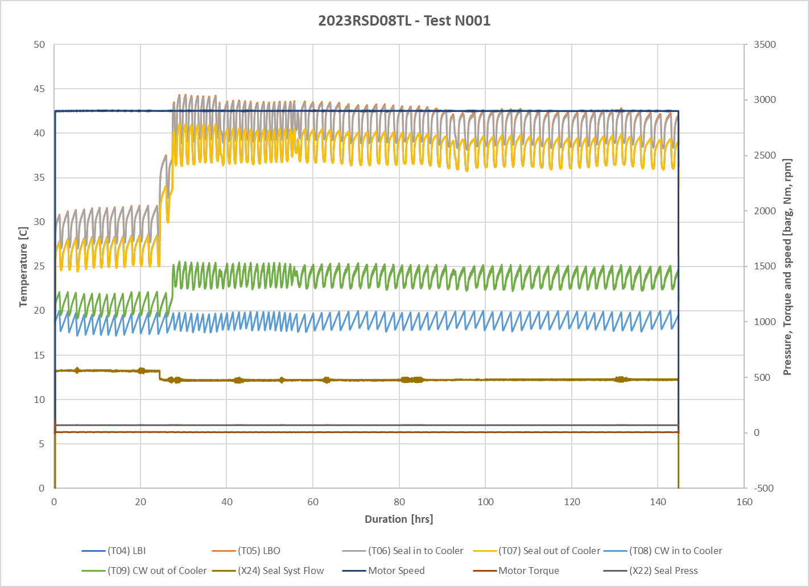
Barrier temperature manually increased.

The first 24h showed stable performance, however, barrier temperature was too low reason for reducing the cooling water flow to have higher barrier temperature.
Leakage was steady during the whole testing period.
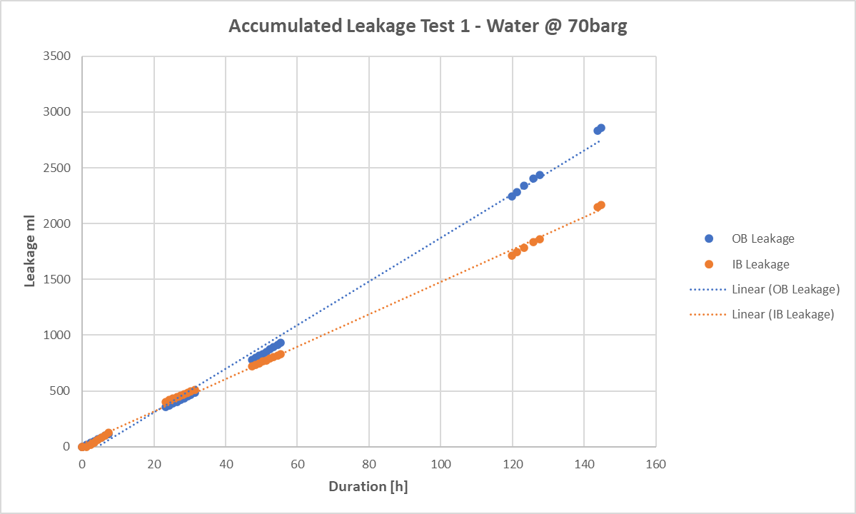

Manually Logged Data

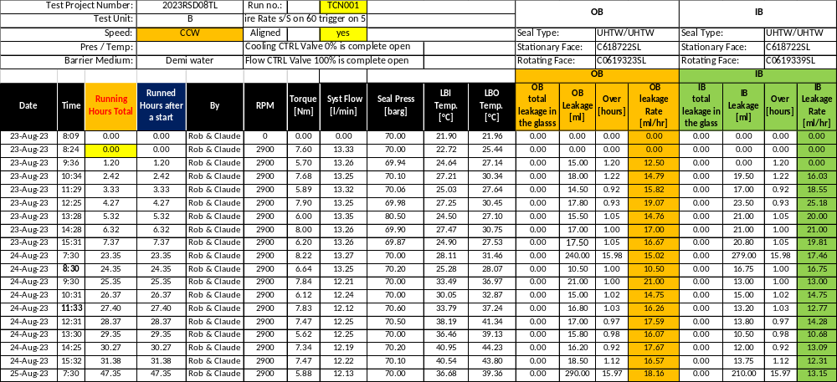

Measurements Results
Leakage rate
 | Inner Seal | Outer Seal
Total Run time [h] | 144.6 | 144.6
Total Seal Leakage [ml] | 2857.6 | 2164.3
Seal Leakage Rate [ml/h] | 19.7 | 14.9

Post-Test Pictures
IB Rotor | IB Stator
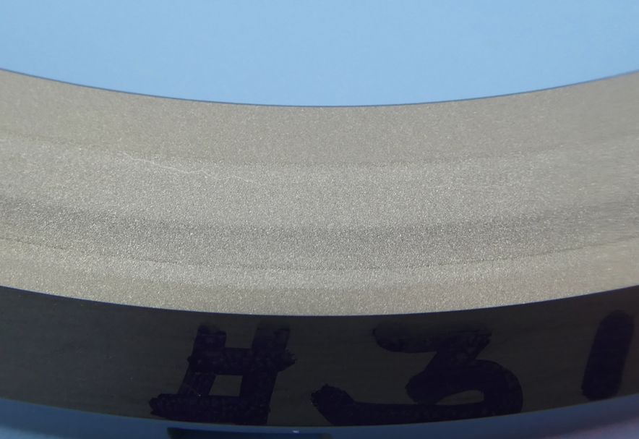 | 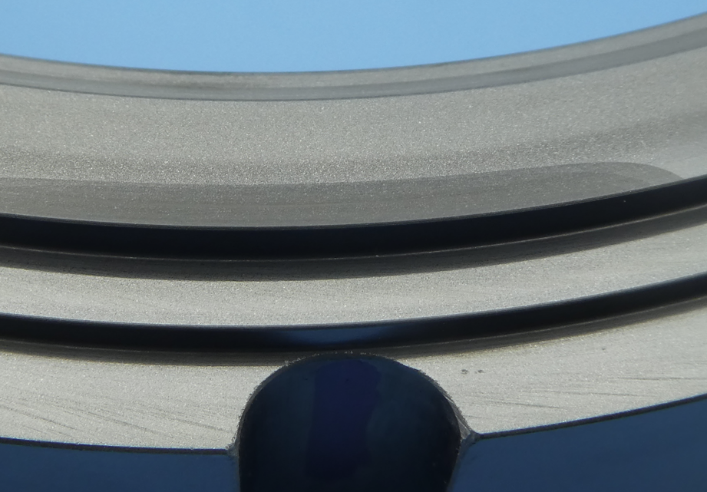
Ra | Ra

OB Rotor | OB Stator
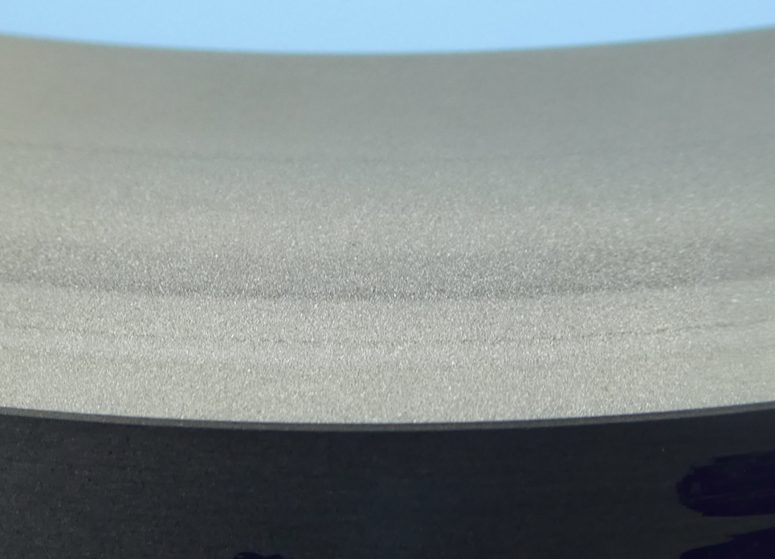 | 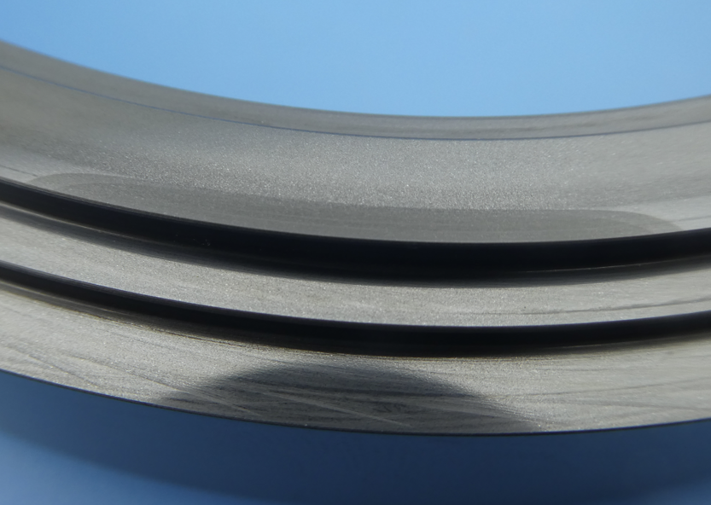
Ra | Ra

Test Conclusion
The first test with newly designed faces (wavy faces) on water has been very successful, the performance in terms of leakage stability and temperature was acceptable.
Seal faces conditions after the test didn’t show any damage or deterioration from running over 144 hours on water. It is therefore considered an acceptable seal faces combination.

